Roger,
I insert comments only on problems I would replace or modify. The others are fine. Anyway, my understanding is that there should be around four embedded questions, not 10.

Jorge

Embedded Questions for

MAC 2311, and MAC2281

Note: I do not see here Related Rates, which in my opinion is an important topic.

- Evaluate the limit:

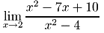

- Evaluate the limit:

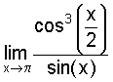 Better yet: ex/ x2 as x goes to +∝ (We should be testing L’H, neither Change Rule -done in separate questions already- nor algebraic manipulation)

- Differentiate:

- Differentiate:

Problems 3 and 4 could very well be integrated into one (with both questions separated)
so : Differentiate a)

b)

- Find the tangent line and the normal line to the curve at the point (2,3):

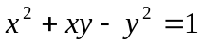,

Better yet: I would ask for a linearization, and its use in a specific problem.

- For the function 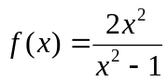 find the following:
The domain
The vertical and horizontal asymptotes
The intervals on which f(x) is increasing/decreasing
The intervals on which f(x) is concave up/ down.
The local extrema. Classify each as a maximum or minimum.
The inflexion points (if any).
Sketch the graph of y = f(x).

#6 is too long, a small mistake in a computation and the problem becomes useless. I would ask for the max-min of a function (even a polynomial) on a closed interval. Any graphing calculator could and will graph the function. But setting the equations for a word problem is meaningful for Engineering students.

How about : Find the slant asymptotes of y = 2 + 5x + cos(1/x) (which is conceptual, and does not require many calculations)

- An object moves along a line. The acceleration function is

a(t) = - 2t. The initial velocity is v(0) = 9.

Find the velocity function v(t).
For the time interval 0 ≤ t ≤ 5, _find the total distance traveled.

- From a thin piece of cardboard 30 in. by 30 in., square corners are cut out so that the sides can be folded up to make a box. What dimensions will yield a box of maximum volume? What is the maximum volume? Round to the nearest tenth, if necessary.

- Integrate:

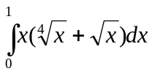

10. Find the derivative of the function:

g(y) =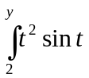dt.

